Instructions project
Main: instruction ( 1 step ka plan bana na haii usko sussfully complete karnaa haiiiii ) aur fir muje puchnaa haiii check karoooo aur fir aage step 2 karnaa haiiiiiiii ) har step complete kar ke deploy karte rehnaaaa
Dekh broo sabse pehleeee
Step : 1 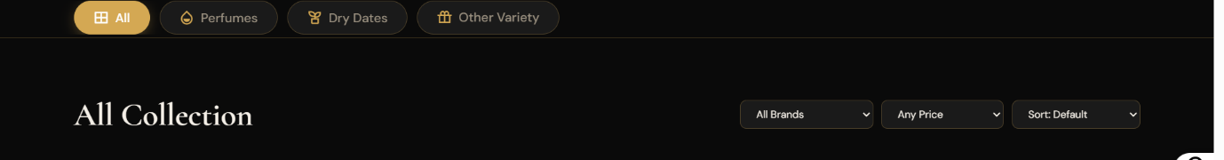
Ye menu line (panel ) me
All perfumes dry fruits other veriaty haii
To ab
All perfumes dry fruits Bakhoor gift pack /combopack other veriaty (aisa 2 item add karnii haiiii
Ye complete kar ke bata o muje

Step 2 :
Dekh abhi item me bohot sara glitch ho gaya haiiiii bohot sari item ki details ke detias aage piche hoo rahiiiii haiiiiii so p 46 tak perfect haiiii usko rehnee dooo uske baad p47 se last tak jitne bhi item haii remove karr doooo
Aur muje bata oo ( khaaas : tu khud j remove kar denaaaaa database se bhiiii )

Aur zyada ka koi bhi folder create mat karnaaa
Zyada ka joo bhi kacharaaaa garbage haii nikaal denaa

Complete kar ke batana

Step : 3 :
( step 2 complete karne ke baad )
Old nahiii me fir se video recored kar raha hu
Aur images bhii joo missing haii vo add kar raha huuuu
( usme step 1 complte karne ke baad )
Bakhoor aurr combo pack ka section aa gaya hogaaaa uski verity bhi haiii me usko ( b1 , b2 aise likhugaaa ) aur combopack koo ( p72 aur p73 aise likhugaaa ) uski detais fetch kar ke total batana kitni item huviiiiiiiii (mene bakhoor ke section me rakhne ki item me b1 se b4 tak rakhna haii )
Kaha see ( p47 se upload kar raha huu
Me fir se video upload kar raha huuu
Us video ko mp4 kooo deep check karr
Usme ( pehlee image haiii uske nicheee uskiiii details haiii soo deep analysis kar kee check karnaa aur mujee commmad me batanaa ke table bana keee ke itnee perfumes haiiii aur itnii detais haiii

Complete kar ke batanaaaa

Step : 4 :
Aaj is project ko final complete ✅✅karnaa haiii ( aur kal client ko sopnaaa haiiii )
Step 1 , 2 , 3 pura complete karne ke baad
Check kar lenaaa codeeee pure project kaa codeeee aur design

Koi bhi device me cut naa hoo glitch naa maree aisaaaa ( zyada ka code nikaal denaaaa )

Fully analysis karnaaaa aur solve kar denaaa

Aur ab aage batanaa ke itnaaa ho gaya ab kya kareeee

Step 5 : final step happy step
Ab finally hamare code ko seo series me add karnaaa haiii
Koi google par sevenstarperfumes likhe to hamari website uppar aani chaiyeee
Direct google par chada deniii haiiii

Aisie final aur majobooot script likhaaa aur processs bhi batanaaaaaa

Aur ab final deploy kar denaaaa

